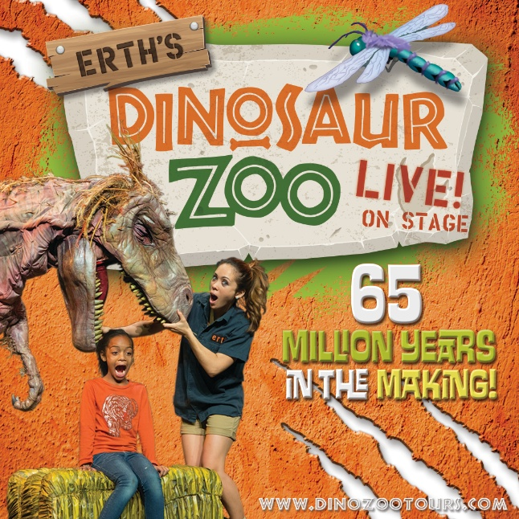

Erth’s Dinosaur Zoo Live

Please contact Catherine Major for all Marketing Inquires
cmajor@cmajorpr.com

Dropbox Link for materials: Erth's Dinosaur Zoo Marketing Materials

