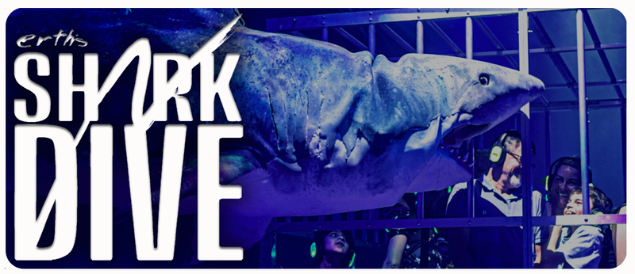

For Marketing Materials
Please contact:

Catherine Major (206) 953 8272
cmajor@cmajorpr.com

